Hello,
Below are directions with screenshots about how to complete and submit assignments using the Wonders/Connected website. If you have any questions please let me know. Remember that you only have to do what is listed on my teacher page and Google Classroom each day. Do not think you have to do the whole packet in one day. I will be assigning the same assignment for 4-5 days that way after you complete each page, I can grade it. Make sure you check the name of the assignment so you complete the correct page. I will grade this like we do in class. You will get completion points for the first four pages, and the fifth page will be graded for a point a piece. When you complete the page that is a point a piece you may use your work from the beginning of the week to help you.
Mrs. Smith

- Go to the connected link on my teacher page or Google Classroom and click my name.
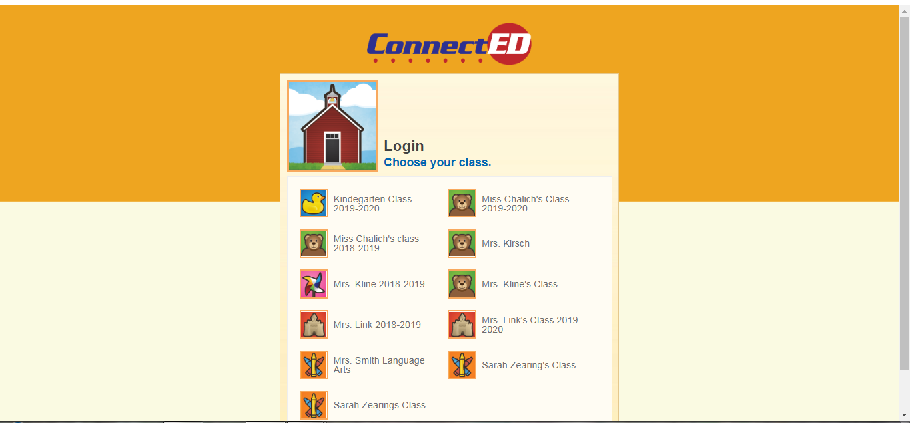

- When you click my name, you will see this page click your name and enter your password.
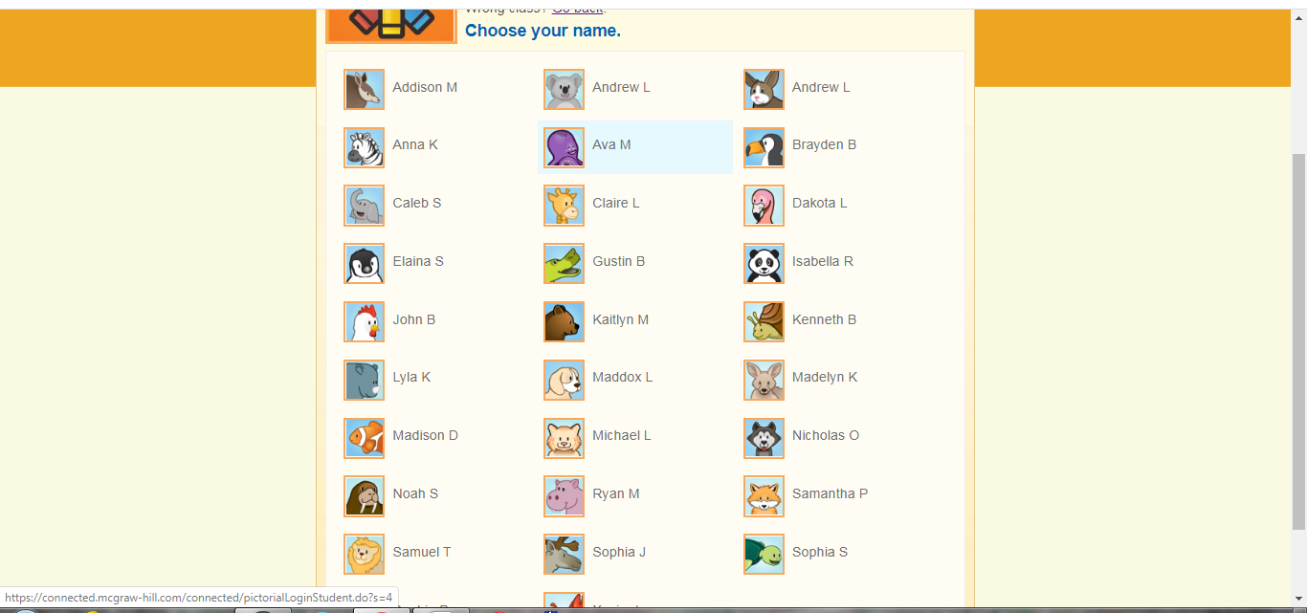

- When you login, you will see this page, and your name will be in the upper right corner. Click launch to get to the next screen.
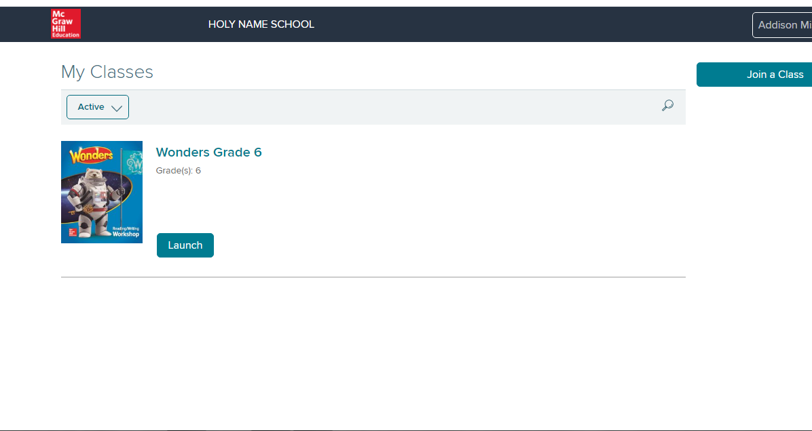

- After you click launch, you will see this page. Click on the To Do tab and it will take you to the assignments.
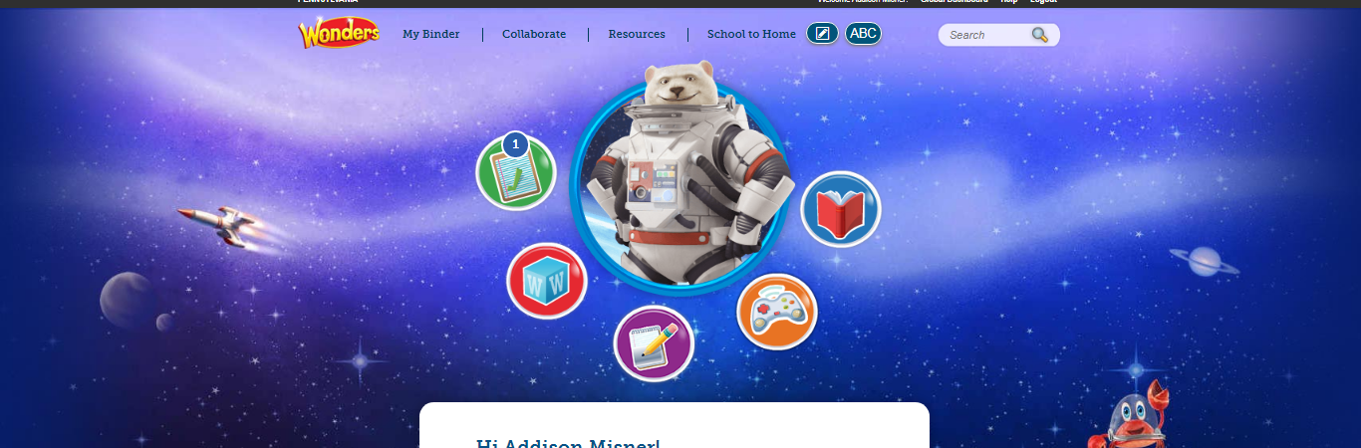

- Your assignments will appear to the right of the screen. To open the document click on the document itself.

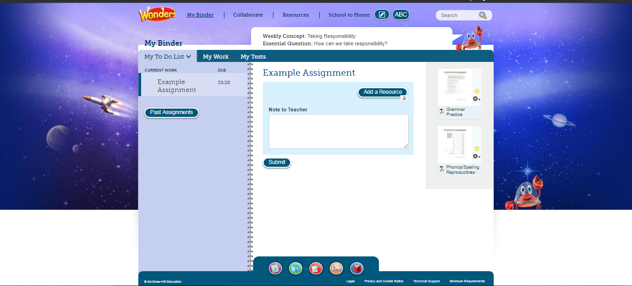

- When you click on the assignment, it will open like this. You may have to use the zoom buttons to see the whole page or expand the screen.
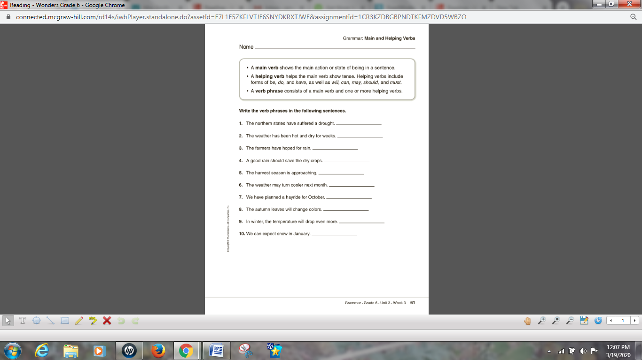

- Click the text button at the bottom of the screen and then click on question you want to answer. When you type, your answer will appear one line below where you want to answer. It is okay I will know what goes with what, it is the formatting of the site and I cannot change it. When you finish your assignment for the day, hit the save button.
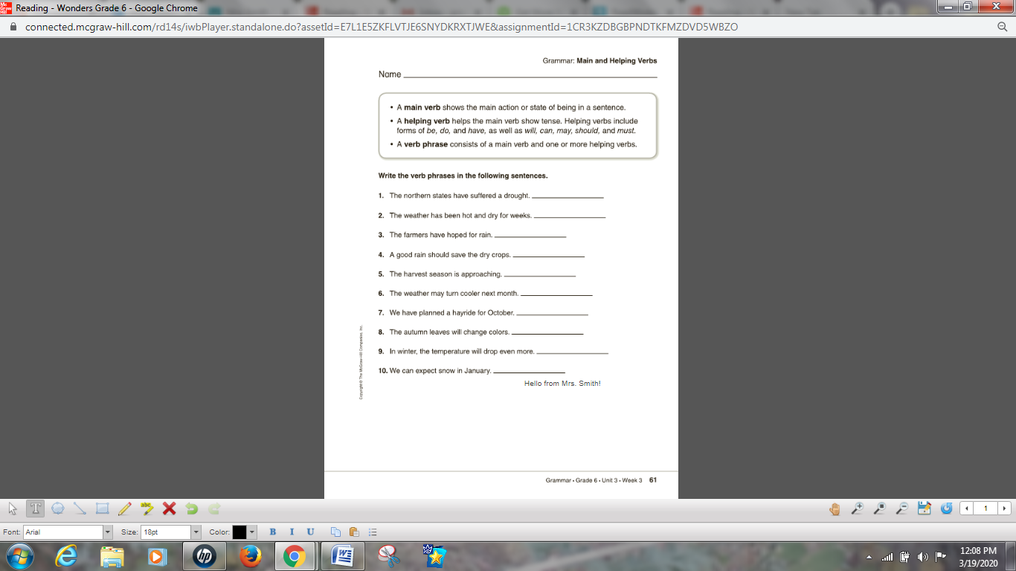
This is the type button.
This is how your answer will appear. I tried to answer number 10 and it typed in below the line.
This is the save button.

- This is what your page will look like when an assignment is saved. You can edit this assignment by clicking on it. As long as you don’t hit submit, you can edit the assignment. I plan to assign the same packet for multiple days so that you can submit one page per day. Please look at the assignment name to make sure you are completing the correct page.
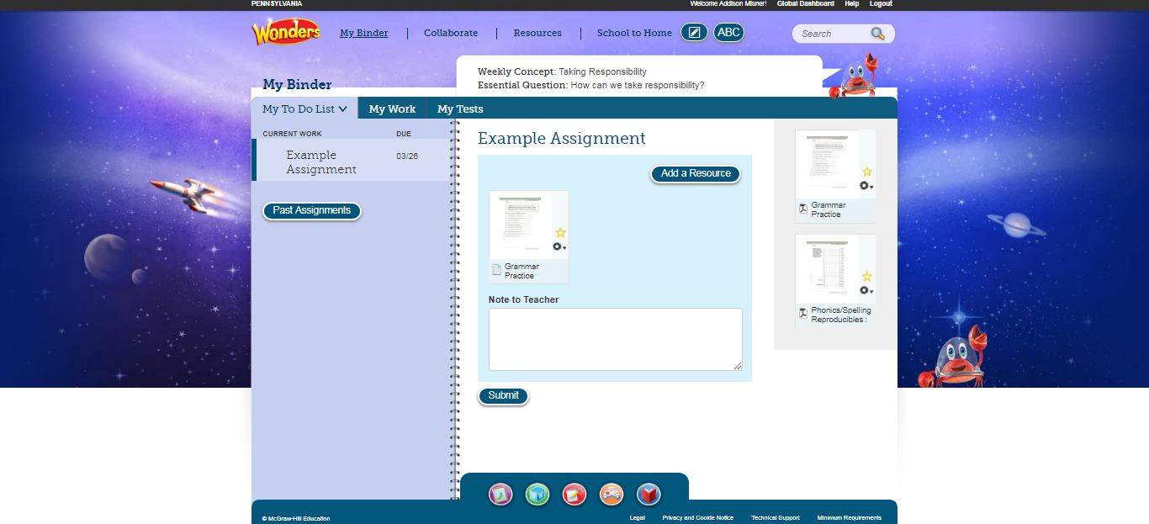

- When you are done with the assignment, hit submit this message will appear after you click the submit button and then hit ok. When you hit submit it will come to me and I will be able to grade it.


